Norwich University of the Arts

Research and Knowledge Exchange Strategy
2022 - 2027

Shape our World

Prepared by Professor Louis Nixon, Sarah Steed, and Professor Simon Willmoth

CONTEXT

We are a vibrant community of practitioners, theorists, and historians, operating at a scale where we can bring creative teams from diverse backgrounds to work together on global challenges.

We have an ambition to be distinctive, and with investment, we can vastly expand.

The Research Knowledge and Exchange Strategy has 5 co-ordinates:

- Audit and map Research and Knowledge Exchange plans;
- Create a broad and embedded Research and Knowledge Exchange culture with creative practice at the core;
- Build from ‘individual’ practice to a ‘partnership’ and project-based model;
- Target impact from the outset;
- Focus on ‘Sustainable Worlds’ and ‘Creative Technology’ Institutes in order to focus and accelerate our work.

This Strategy will enable the University to become increasingly active in Research and Knowledge Exchange by 2027 and will create the platform to become an institution in which Research and Knowledge Exchange are integrated in all that we do.

We aim to be prominent in action and debate at local, regional, and national levels, achieving critical mass in key areas of debate. This will deliver new solutions to global challenges, attract new thinkers to our community, and engage a broader cross section of the academic community in Research and Knowledge Exchange.

The Strategy will support greater synthesis between Research and Knowledge Exchange enabling Research to flow into Knowledge Exchange, and Knowledge Exchange (particularly at the industry project level) to develop and flow into Research.

The Strategy will create a framework for investment decisions within finite resource, whilst encouraging the development of Research and Knowledge Exchange professionals at all career stages.

Norwich University of the Arts Research and Knowledge Exchange Strategy 2022 - 2027
(“The Strategy”) sets out a framework for the development of a vibrant Research and Knowledge Exchange culture for the University. We will do this through establishing three Research and Knowledge Exchange institutes which will build critical mass and focus in key areas of debate.

The Strategy aims to invigorate the life of our university community and positively impact our regional, national, and global communities. In bringing Research and Knowledge Exchange together, The Strategy underpins the virtuous circle of Knowledge Creation and Exchange.

The Strategy responds to the University Strategy and Operational Plan 2022 - 2027 and the following key Research and Knowledge Exchange KPI’s within that plan.

THE STRATEGY

SHAPE OUR WORLD

Creative arts practitioners, historians and theorists can help solve some of the world’s biggest problems.

Aim

Our aim is to demonstrate how creative approaches can help solve complex global problems in order to bring about long-lasting transformation in our city, region and beyond. To do this we will build a sustainable, focused, partnership-centred Research and Knowledge Exchange community.

We will combine our inquiry-led pedagogy with our research practice to connect with the research and practice of other institutions, organisations, and disciplines, to develop encounters and projects that will produce new knowledge and make us a partner of choice.

Our Strategy sets out to support those engaged in individual projects and areas of specialism, and also strategic and collective areas for focus and further investment. At the core of our mission is a belief that diversity in all its forms - national, cultural, socio-economic, political, sexual, physical, neurological, and experiential - is the very heart of creative endeavour, enabling us to debate with one another, see the world differently, and create new possibilities for a more equal and sustainable future.

Objectives

The Strategy has four objectives:
- To transform our institutional culture and environment, enhancing quality and developing intensity;
- To deliver major Research and Knowledge Exchange initiatives in chosen fields of endeavour;
- To become a partner of choice in these fields;
- To target Research and Knowledge Exchange impact at sector, system, and societal levels.

To do this we need to build a sustainable, focused, partnership-centred Research and Knowledge Exchange community.
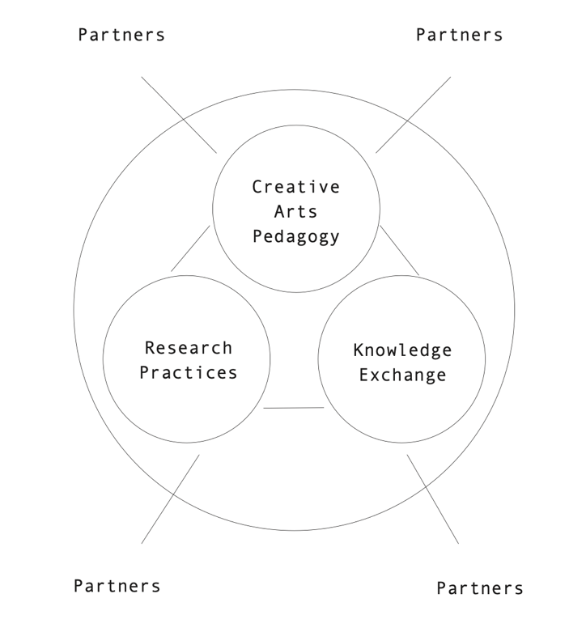

OUR KNOWLEDGE BASE

Creative and critical intelligence

- Technological competencies;
- Embodied knowledge;
- Material understanding.

Exchanges and encounters

- Performances and Exhibitions;
- Archives and Collections.

Communities and partnerships

Norwich is the right place, with its radical history and enterprising spirit, it is a city in a region that has significant potential and strong links to the big topics: agriculture, climate change, creativity, and technology.

We can unlock our potential through the Creative Quarter, Bank Plain, East Gallery and our new Institutes that build on existing strengths and connect local and global challenges.

We have a knowledge base which is valuable and our work in Creative Technologies, Arts and Health and the Coastal Environment has achieved degrees of impact and change. The University has a solid Research and Knowledge Exchange foundation, but few of our projects and activities are driven through external funding. There are important correlations between external funding and quality Research and Knowledge Exchange, and we need to increase funding activity and support to reach our potential and sustain our future work. As a small specialist institute, we have advantages, but if we are to fulfil our ambition to make a difference to the city, the region and beyond and to show that creative thinking and practice can make breakthroughs, we need to build our capacity, become sustainable over time, and enhance the quality and impact of our work. This requires re-gearing, reform, intervention, and investment.

STRATEGY OVERVIEW

The Strategy is a five-year strategy within a 10-year vision which will build quality, capacity and a sustainable Research and Knowledge Exchange culture. The Strategy recognises the value of individual research activity, through creating a culture that supports all our staff and students in their intellectual, creative, and personal growth. In addition, the Strategy increasingly focuses our work on building interdisciplinary teams which will enable us to address global challenges and distinctive themes to engage and attract partners and funding streams and to target and deliver impact. The Strategy will enable us to establish and present our civic ambitions and commitment to working in partnership and to make a difference to the future of Norwich and the wider region, working with civil society and industry partners on ambitious development projects, recognising the links between global challenges and local experiences.

STRATEGY DIAGRAM

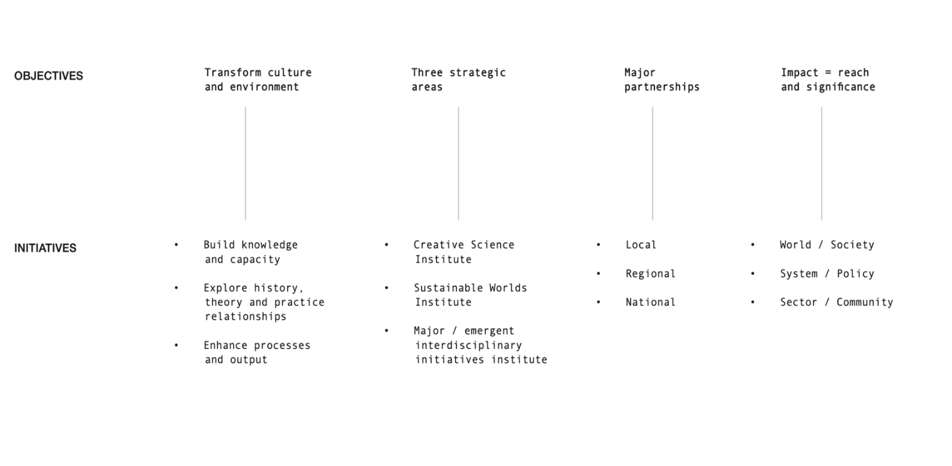

THE STRATEGY AIMS AND KEY ACTIONS

Objective 1

We are a community of practitioners, historians, and theorists all of whom contribute to the production of new knowledge.

We will escalate quality and intensity over time specifically in relation to capacity and funding.

Initiative 1.1:

Build knowledge of, and capacity for, research and knowledge exchange.

To:
- Become ‘increasingly Research and Knowledge Exchange active’ by 2027;
- Increase academic staff on the Research and Knowledge Exchange pathway with approved ADR plans from 40% - 80% by 2026;
- Increase registered PhD students from 7-20 by 2026;
- Increase staff and student engagement in Vice Chancellor lecture series from 20% to 70% by 2026.

We will:
- Embed a culture of Research and Knowledge Exchange that recognises, celebrates, and supports diversity in all its forms;
- Cultivate strong Research and Knowledge Exchange leadership through the appointment of Institute Directors and involving and engaging the professoriate in mentoring and support;
- Develop effective support structures for our Research and Knowledge Exchange community through training and support and bringing in specialist expertise externally when needed;
- Build capacity and sustainability through increased funding to support appointments of post-doctoral and research fellows, linked to areas of strategic importance;
- Increase collaboration opportunities through structured programmes of events, lectures, conferences, symposia, exhibitions, and performances;
- Enhance the quality of our research degrees programme and increase PGR student numbers, through a programme of studentships and bursaries;
- Enhance mechanisms for the training of postgraduate research students and early-career academics, while supporting the development of mid-career and senior Research and Knowledge Exchange academics;
- Support a skills development strategy regionally and nationally through flexible, industry-driven course innovation;
- Build our graduate entrepreneur community through start-up and scale-up support.

Initiative 1.2:

Explore history, theory, and practice relationships.

To:
- Evolve our understanding of practice-based approaches;
- Develop greater synergy across modes and methods of research;
- Enhance Critical and Historical Studies research;
- Enhance support for practice research;
- Increase percentage submission of practice research to REF 2027.

We will:
- Support creative Research and Knowledge Exchange in all its forms and across a broad range of research activities and output types through training and building interdisciplinary teams, through the institutes and major interdisciplinary and emergent research initiatives;
- Explore models to strengthen interaction between history, theory and practice to create the conditions for outstanding Research and Knowledge Exchange;
- Embed Research and Knowledge Exchange in all levels of academic activity (undergraduate, postgraduate, research degree, early career, and established researcher);
- Conduct world leading and distinctive Research and Knowledge Exchange within university programmes, research groups and institutes.

Initiative 1.3:

Enhance the quality of our resources, processes, governance, and outputs.

To:
- Support the expansion of activity and delivery of the strategic objectives;
- Increase the volume of internationally significant and world leading research overall 4* and 3* from 71% to 80%;
- Increase the percentage of eligible staff submitted to next Ref from 30% to 45%;
- Deliver improvement in REF and KEF performance within the appropriate timescales.

We will:
- Form a new Research and Knowledge Exchange support office to improve processes, support projects, facilitate growth, enhance communication, and provide governance and support for ethics;
- Establish Research and Knowledge Exchange frameworks and structures that support excellent and world-leading research through the directorates, institutes, research degrees and the East Gallery programme and fellowships;
- Create a sustainable Research and Knowledge Exchange environment to increase and diversify sources of external funding to support expansion, build capacity, research quality and reputation;
- Develop our Research and Knowledge Exchange facilities, archives, and resources to support research excellence.

Objective 2

We will focus Research and Knowledge Exchange through major research institutes, which lead creative responses to local, national, and global challenges.

To:
- Provide institutional focus and align our strategic priorities, with funding streams and work on 21st century problems and topics to engage funders;
- Increase number of RKE bids submitted over 100K from 2-10 by 2026;
- Increase number of RKE bids awarded over 100K from 1-4 by 2026.

We will:
- Launch two new Research and Knowledge Exchange institutes to ensure the distinctiveness, and increase the impact of our Research and Knowledge Exchange
- Support ground up projects from directorates and research groups through a third institute (Major Interdisciplinary and Emergent);
- Develop projects where we have a track record including arts, health and wellbeing, the environment (including coastal erosion and Agri-tech), creative technologies, art and design practice and critical and historical studies;
- Lead in developing creative responses to national and international priorities.

Initiative 2.1:

Creative Technologies Institute: Virtual production, AI/XR, Coastal Erosion, Agri-Tech, Arts Health, and Wellbeing.

Initiative 2.2:

Sustainable Worlds Institute: Coastal Erosion, Agri-Tech, Arts Health, and Wellbeing.

Initiative 2.3:

Build towards a third Research and Knowledge Exchange institute (name to be confirmed): which will be interdisciplinary and brought into focus through emergent initiatives, projects from within Directorates and Research Groups.

RESEARCH AND KNOWLEDGE EXCHANGE INSTITUTES

The Institutes will be focused but there will be significant areas of synergy, overlap and flow between activities.

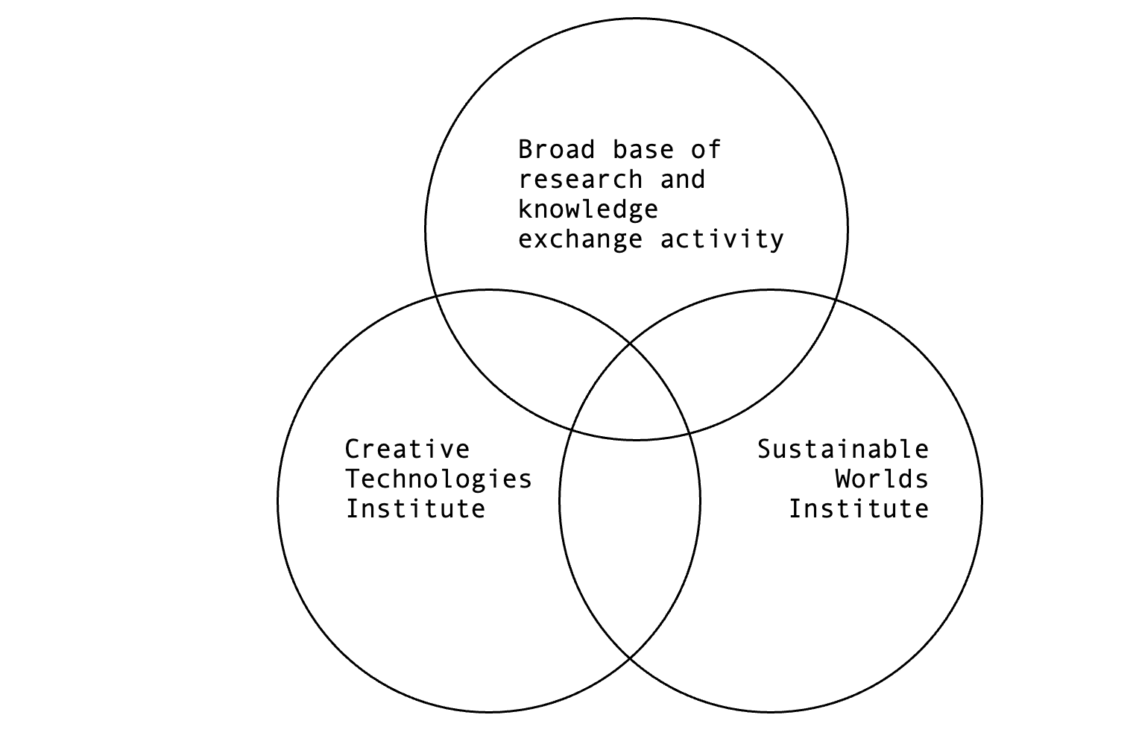

Objective 3

We will become a partner of choice in the key fields through an open innovation approach, so that we are part of the economic and social success of Norwich and Norfolk, and beyond.

To:
- Broaden and diversify our networks and partners to make the region a more fertile place to work;
- Work on strategically important areas in partnership.

We will:
- Work with a quadruple helix approach - University – Industry – Government - Civil Society
- Structure our approach to partnerships to diversify and work strategically at local, regional, and national levels and to engage new partners and networks;
- Grow and diversify our networks and partners, regionally, nationally, and internationally, both organically and through focussed partnership development and aligning our work to the needs of key partners;
- Lead debate on Research and Knowledge Exchange in the sector through strategic partnerships with local, regional, and national organisations which will create a platform for meaningful international engagement;
- Commit to working in partnership with appropriate communities and organisations in the public and private sectors, locally, regionally, and nationally to create a platform for meaningful international engagement through projects which have global significance and reach;
- Increase activity and visibility at locally and regionally through the developing creative quarter and through strategic projects in Bank Plain and East Gallery to build public engagement and share our civic ambitions;
- Communicate, and promote our Research and Knowledge Exchange activity to reach the public, our partners, and collaborators more effectively across local, regional, and national arenas, to become a partner of choice and attract new partners.

Initiative 3.1:

Become a hub for cross-discipline practice and research for the university community, and the wider public through our work on the creative quarter.

Initiative 3.2:

Virtual production / Studio East. Continue our research and work to build the region’s first NetZero Film studio working loosely with it.

Initiative 3.3:

Build upon our collaborations with national organisations to deliver change and build impact.

Objective 4

We will target higher levels of impact, showing where creative thinking can make breakthroughs.

To:
- Increase the quality and number of impact case studies in the next REF cycle. Target and orientate towards tangible impact to make us more investable;
- Develop our approach to impact to look forwards to maximise reach and significance and target positive change;
- Advance the societal, cultural, and economic benefit of the creative arts to deliver impact.

We will:
- Ensure our underpinning research is aligned and maximised;
- Increasingly work at the outset to orientate, structure, embed and target specific levels of impact and change and show that there are important challenges and areas where creative thinking can make breakthroughs;
- Build the reach, reputation, and impact of our Research and Knowledge Exchange activity regionally, nationally, and internationally and maximise the synergies between our Research and Knowledge Exchange activities;
- Target our impact case studies to specific areas: sector/community, system/policy, world/society and ensure the underpinning research and the reach and significance of our work is aligned and maximised;
- Support interdisciplinarity, sector growth, and the creation of high-quality graduate employment, in our region and nationally to strengthen the creative industries, through significant projects such as Studio East;
- Support the development of the creative sector in our region by promoting infrastructure development and industry-based research and development.

VISIBILITY

East Gallery

As a hub for cross-disciplinary practice and research for the university community, and the wider public, over the next five years East Gallery will seek to develop and support new arts and media research and practice by providing a more inclusive and diverse programme.

East Gallery will proactively engage with our students and support the Research and Knowledge Exchange culture through creating a programme of high-quality, vibrant, and inspiring exhibitions and events, enhancing the creative environment of the university.

As well as supporting a programme of diverse international external projects, the East Gallery will present research generated though the university, either within its student or academic community, and provide opportunities to create new work under a fellowship programme each year.

Norwich University of the Arts web site

We will need to develop and maintain a dedicated area on the website that fully represents the strategy.

News media

Enhance Research and Knowledge Exchange communication and presence in the news media and social media.

Research newsletter

Produce a monthly Research and Knowledge Exchange newsletter.

Research Podcasts

Produce a series of Research and Knowledge Exchange podcasts.

